**Develop an application that makes use of database.**

Aim: to develop an android app that makes use of a data base.

Procedure:

1. 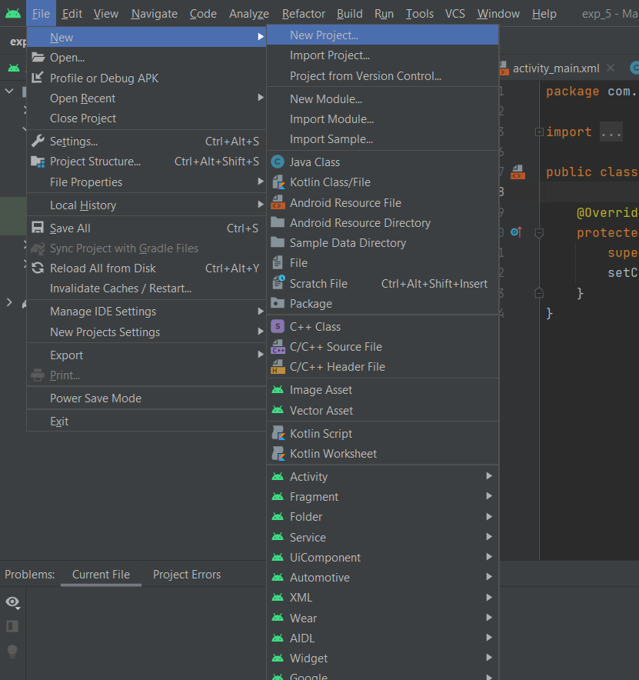Create a new project. Go to the **FILE->NEW->NEW PROJECT.**
2. Select **EMPTY ACTIVITY** and proceed with default settings. Click on **FINISH.**

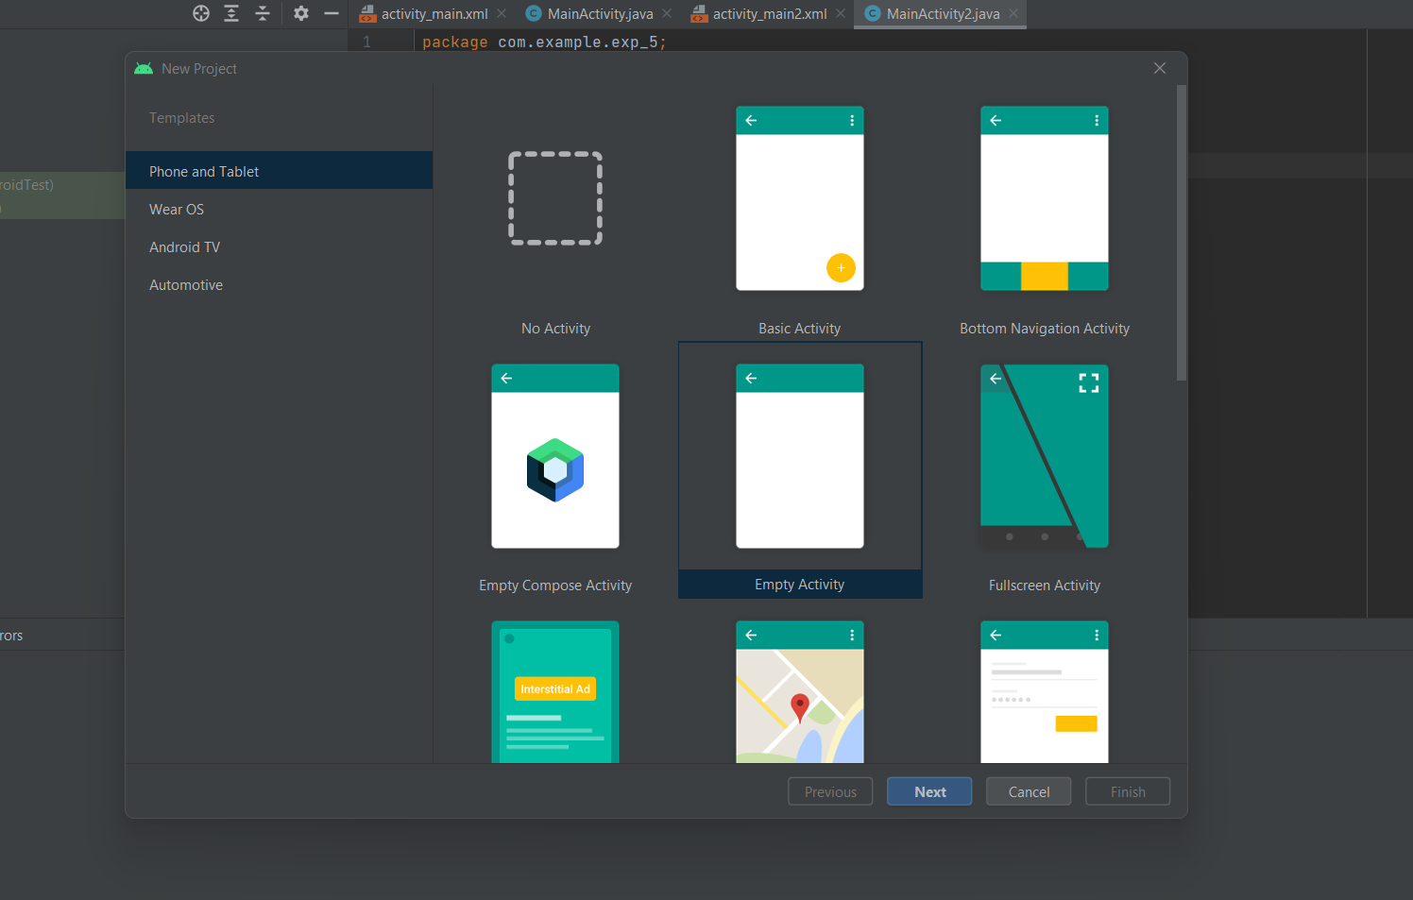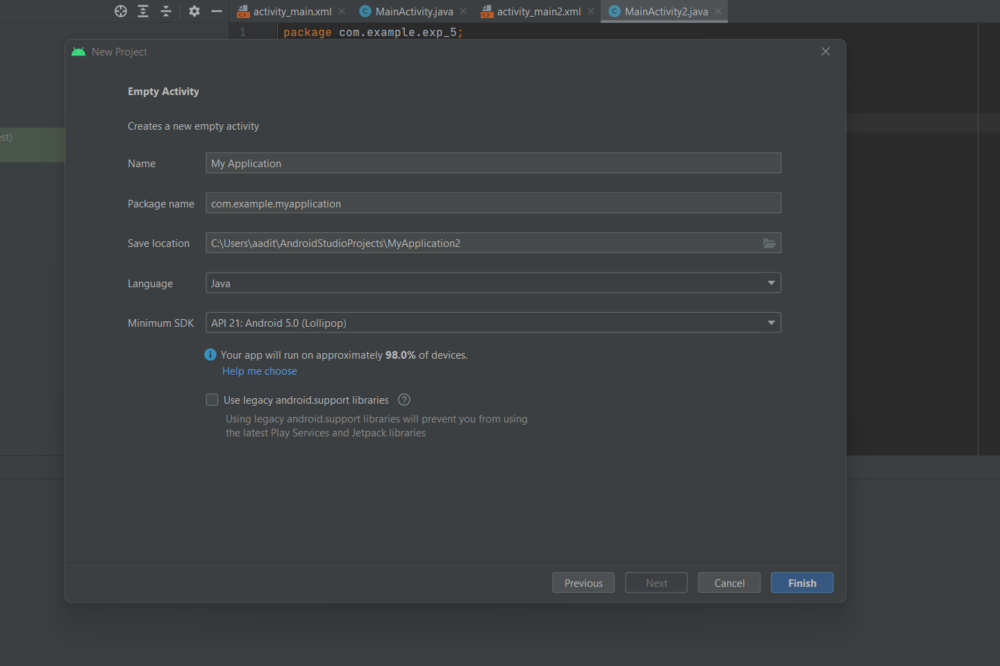

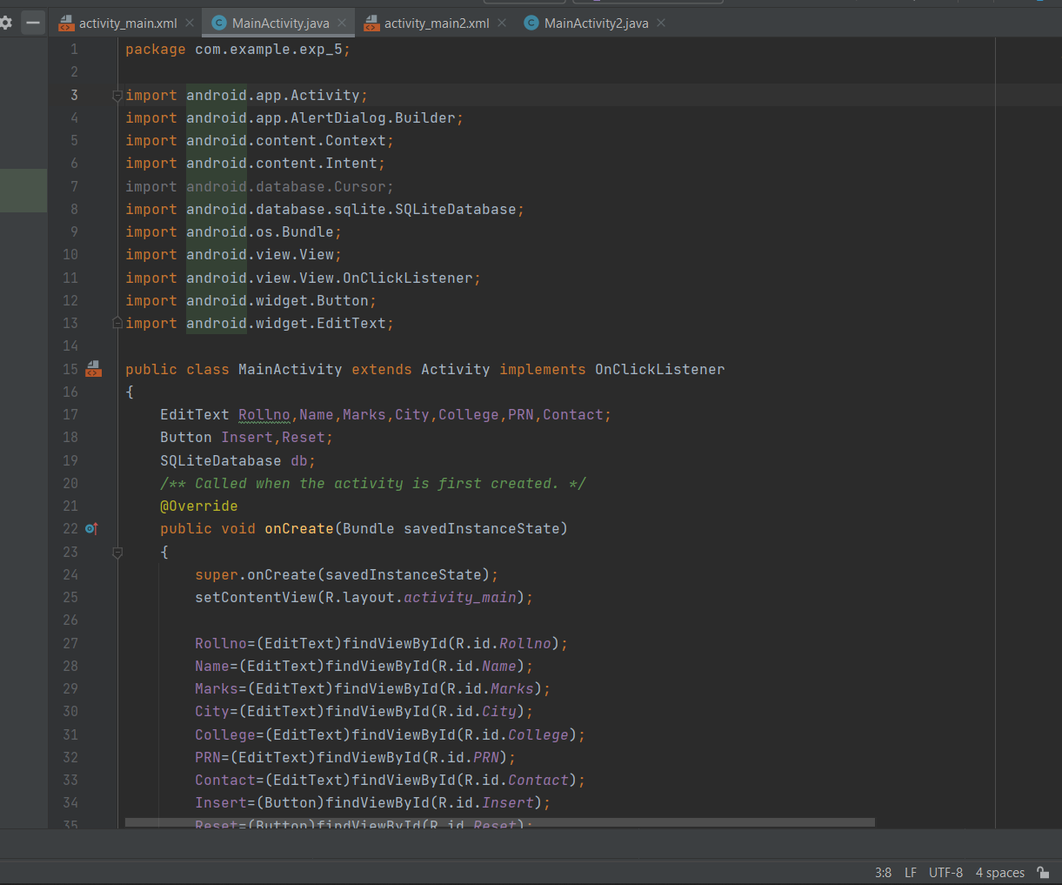**main activity java file:**

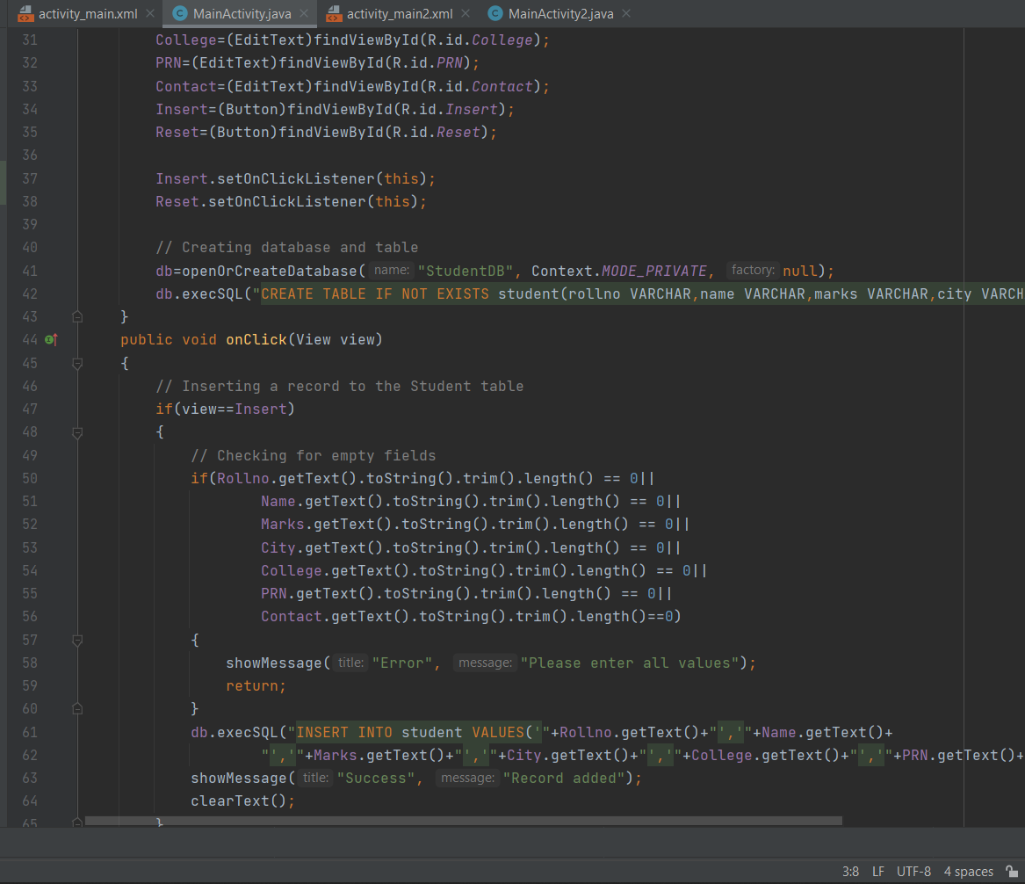



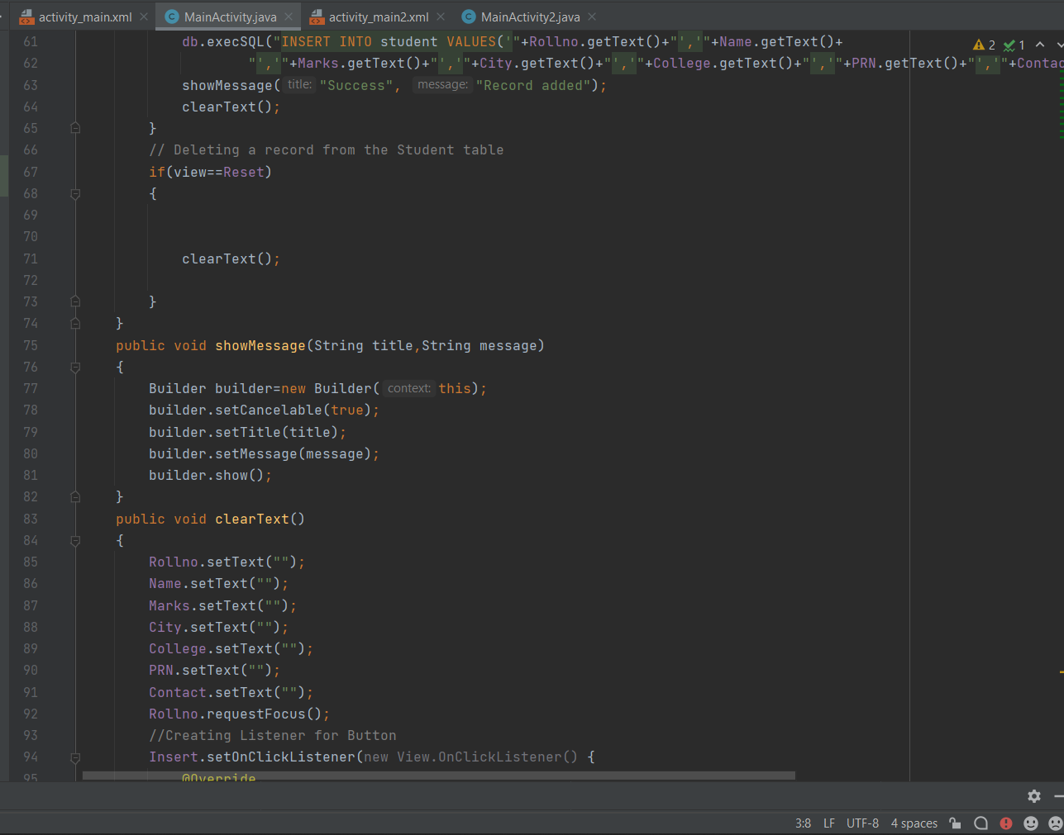

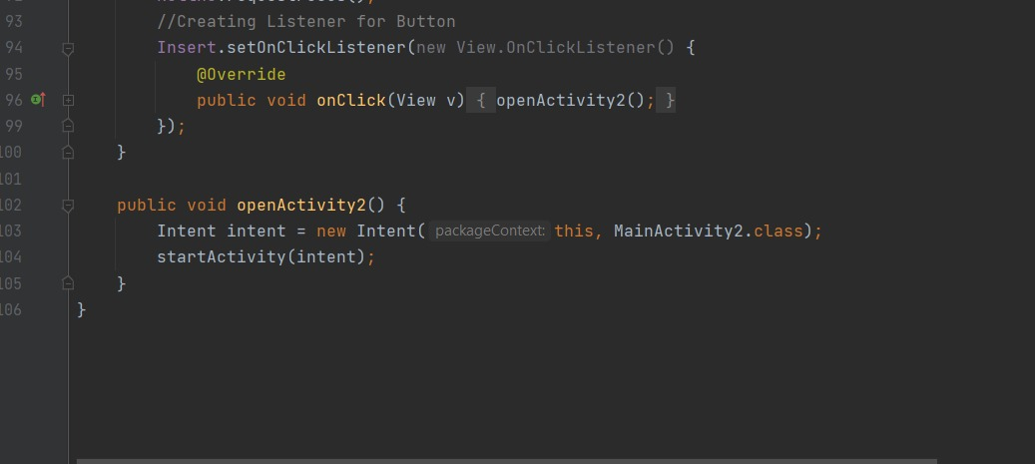

Main Activity 2 java file

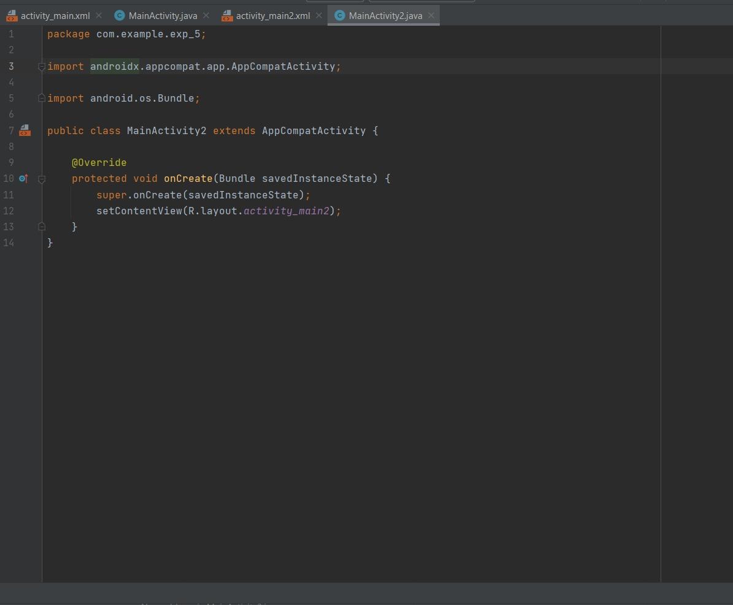

Main Activity XML

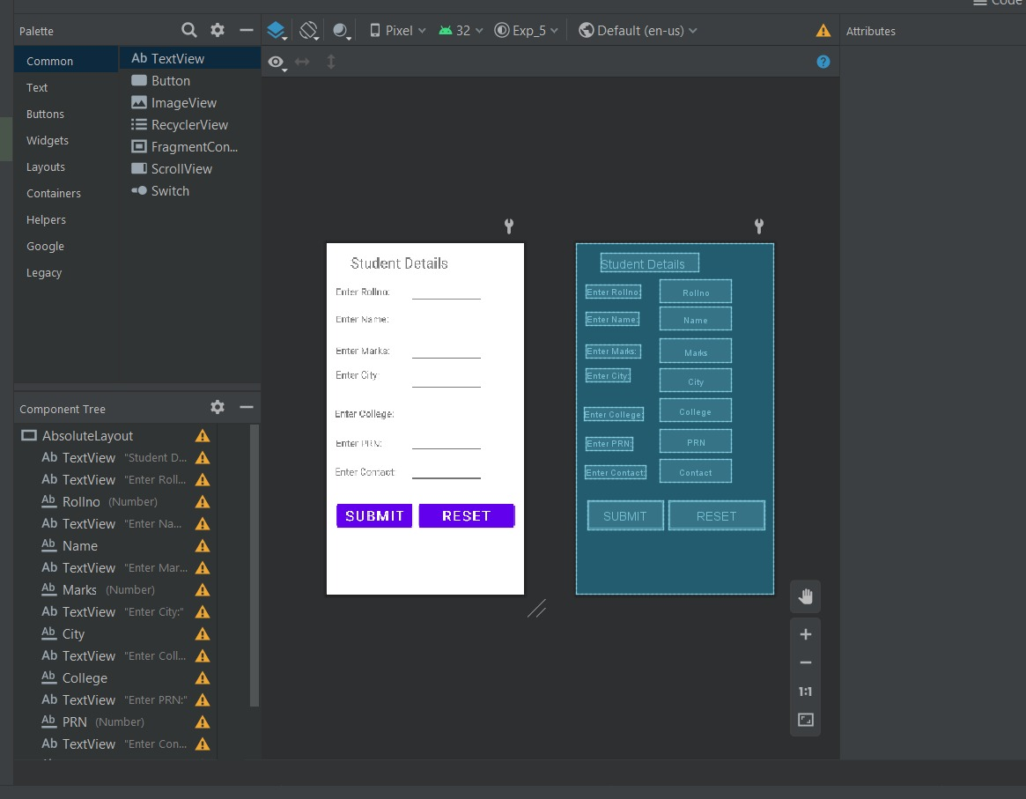

Main Activity 2 xml

